Research Question (1 pt):
Name:
Date: Period:
- Is a Jumping spider faster than a Marbled Orb Weaver at climbing a vertical wall?
Hypothesis (2 pts):
- If timed climbing a wall, I believe the Web Builder (Marbled Orb Weaver) will be faster than a Wandering Spider (Jumping Spider) because the web builder spends its entire live on vertical surfaces.
Variables:
- Independent Variable (2 pts) :
  - Type of spider (Jumping Spider vs. Marbled Orb Weaver).
- Dependent Variable (2 pts):
  - Time (seconds) it takes to climb a wall.
- Control Variables (at least 5) (2 pts):
  - Type of spider (Jumping Spider and Marbled Orb Weaver), size of spiders (both are about 1 cm in diameter), room temperature, lighting, timer, wall, and 3 trails for each spider.
Procedures (at least 10) (6 pts):
- …
- …
- …
- …
- …
- …
- …
- …
- …
- …
Data Collection Procedures (2 pts):
- Once the spider is released on the wall, begin timing. After 30 seconds place the spider back in the container and measure how far it climbed in centimeters. Allow each spider three trails.

Materials (2 pts):
- Jumping Spider
- Marbled Orb Weaver
- Gloves
- Paint Brush
- Timer
- Vertical Wall
- Timer
- Paper
- Pencil
Data from Experiment (include graph) (5 pts):
- The Jumping Spider totaled 190 vertical centimeters in 90 seconds. The Orb Weaver totaled 203 vertical centimeters in 90 seconds. The Orb Weaver's times were also more consistent and it traveled in a straight line.
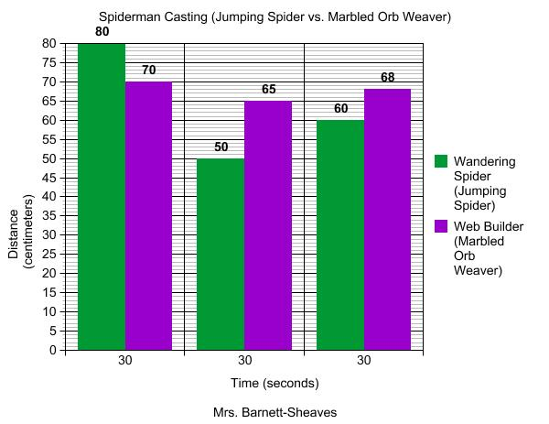
Conclusion (6 pts): Include: Does the data prove or disprove your hypothesis, what would you different next time, how would you experiment be useful to the world?
- According to the data, the Orb Weaver was faster at traveling a vertical wall than the Jumping Spider. This proves my hypothesis.
- If I were to repeat this experiment I would make a track on the wall so that the spiders travel in a straighter line.
- First of all, I believe that Spider Man should be based on an Orb Weaver not a Jumping Spider. The data could be useful in studying the Orb Weavers vertical climbing ability so that one day people would no longer need ladders and other devices to climb.
Total Score: / 30 = %
Comments:

